Testing Instructions

How this stage works:

1. Every trial will begin with this prompt:



If you need to take a break, now is the time to do it. The test will not progress until you press the ‘Space’ key.

1. During the test phase, you’ll see a bunch of flashing colored circles like so:

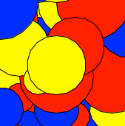

If at any point you think you see ***anything*** other than the colored circles, press space ***as quickly as possible***.

1. Once all the trials are done, we’ll test whether you remember the names of the figures once again. If you successfully remember all 4 names, you will be paid $5 extra.

Some reminders:

* During the whole period of a trial (which will last a maximum of 2 seconds), ***stay focused on the little red dot in the middle***.
* Before each trial begins, make sure you can only see one box (this will be explained to you before this stage begins). If you see ***anything*** other than one box, adjust your head’s position until you only see one box.
* Feel free to take quick break to rest your eyes between trials.
* This stage – depending on how quick you are to respond and how many breaks you take – should take about 20 minutes.